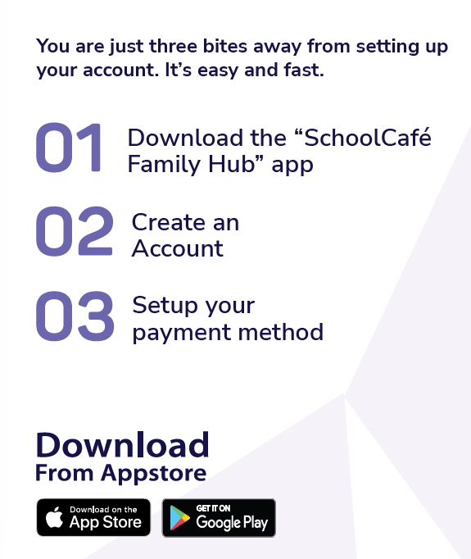
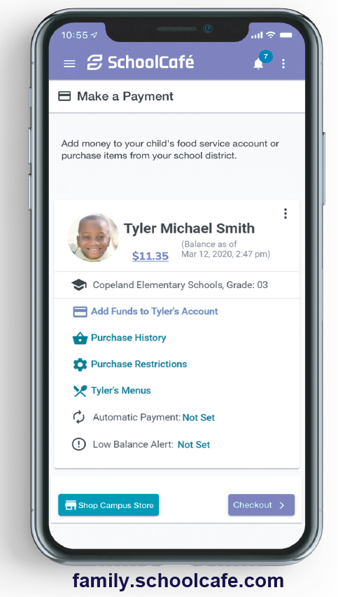

HIGH SCHOOL
The Institute for the Creative Arts is going to a no-charge policy in 26-27! Make sure that your child’s account has money available so that they can get that extra slice of pizza on Friday’s, items off the a la carte menu or a second entrée. We do take cash on site at the school but prefer funds to be added online. This is so Breakfast and/or Lunch runs smooth. The Child Nutrition Director will send out balances each week for your convenience via email.
Go to family.schoolcafe.com or download the app to set up your account if you haven’t already. You will need your student id (not your PIN) to get started.
Email nchronister@icafortsmith.org for questions about your account.

This institution is an equal opportunity provider.

